**LAB 8**   
**AIM: To draw collaboration diagram of ATM**   
**THEORY:**   
A **Collaboration Diagram** (also known as **Communication Diagram**) is a type of **interaction diagram** in UML (Unified Modeling Language) that illustrates how objects interact with each other to fulfill a particular functionality. It emphasizes the **structural organization** of objects and the **messages exchanged** between them.

**Key Features of a Collaboration Diagram**   
 1.**Objects & Actors**: Represented as boxes, showing entities participating in the interaction.

2.**Links/Associations**: Lines connecting objects, indicating relationships.

3.**Messages (Method Calls)**: Numbered arrows showing the sequence of interactions.

4.**Sequence Order**: Messages are labeled numerically (1, 2, 3...) to define the order of execution.

**Purpose of a Collaboration Diagram**   
 • Helps **visualize object interactions** in a system.

• Emphasizes **how objects are linked** and their communication rather than focusing on **time-based sequence**  (as in a Sequence Diagram).

• Useful for **designing object-oriented systems** and refining use case scenarios.

**Example Use Case**   
In an online shopping system, a customer object interacts with the shopping cart, which in turn communicates with the payment system. The collaboration diagram visually represents these interactions.

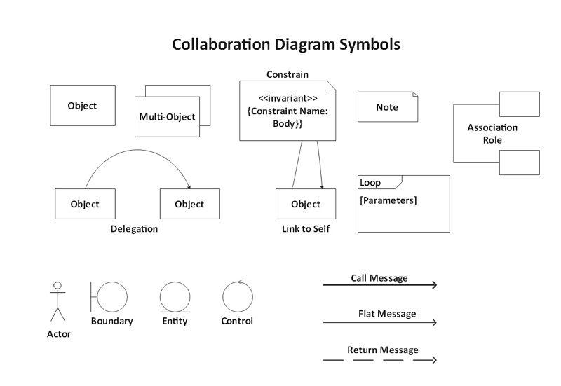

a) Collaboration diagram of ATM

